Applied Orbital HW 2 Report
Problem 1:
Time of Periapsis, [seconds]: 0
At t = 0 [seconds], Initial True Anomaly [radians]: 2.757076582542249e-28
r_IJK: [ 1.884202648346351e+03, 3.303972977795274e-13, -7.031940015384417e+03]
v_IJK: [4.404255738573992e-16, 9.704371673898565e+00, 5.739737827011385e-16]

Problem 2:
At t = 0, Initial Eccentric Anomaly [radians]: 1.112406766137864e-28
At t = 0, Initial Mean Anomaly [radians]: 3.11473894518602e-29
At t = tf, True Anomaly [deg]: 150.6356233451996
At t = tf, Eccentric Anomaly [deg]: 114.00115302603311
At t = tf, Mean Anomaly [deg]: 76.31503533406642

Problem 3:
At t = tf, r_IJK [km]: [-7.582267165812676e+03, 1.648325048363200e+04, 2.829740629937419e+04]
At t = tf, v_IJK [km/s]: [-7.160642645796144e-01, -8.548810047579908e-01, 2.672388216895564e+00]

Problem 4:
As expected, the change in energy is 0. Due to the conservation of Energy, the difference between potential and kinetic energy should be 0 (as seen in the graph below). Although Fig 2 indicates an increasing oscillatory behavior, these increases occur at a negligible order of magnitude. Potential sources for increasing energy may be due to external forces and propagated errors during calculation.
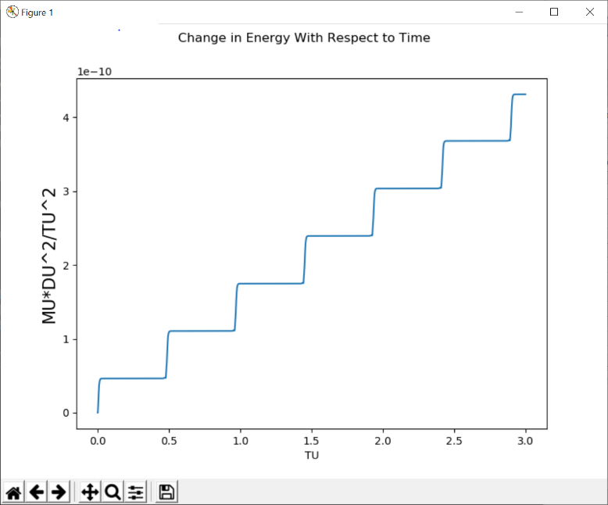
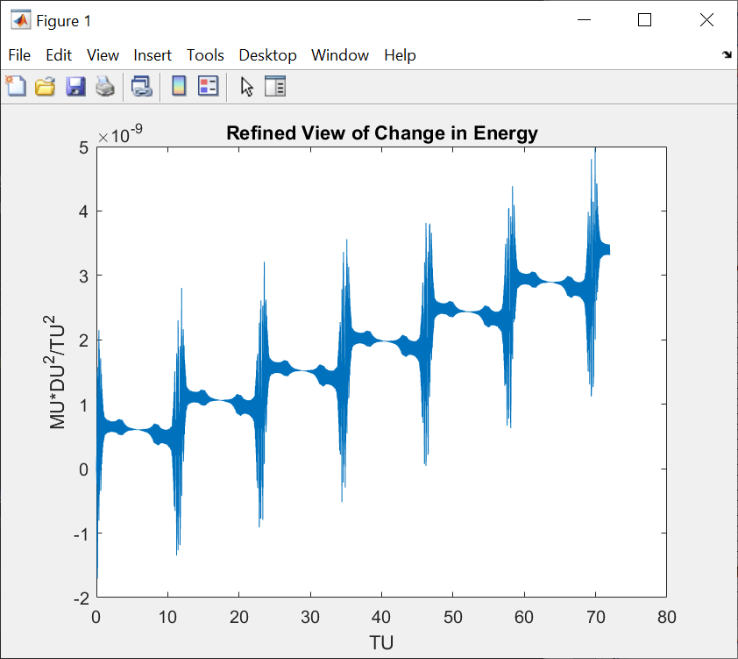

Fig 1 Fig 2

Problem 5:
Error in r at Tf: [ 7.159721462812740e-06, 9.501429303782061e-06, -2.672071059350856e-05] Magnitude of Error Vector in R 2.924953238706339e-05
Error in v at Tf: [-8.336727974622704e-10, 1.894042256367356e-09, 3.111312540937661e-09] Magnitude of Error Vector in V 3.7366659108796006e-09
Problem 6:
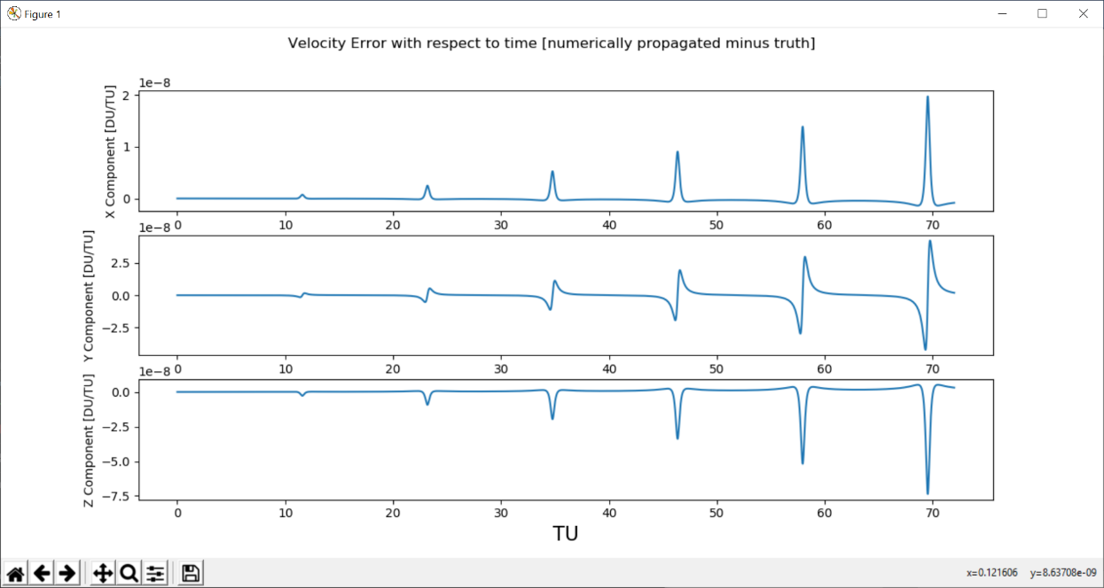
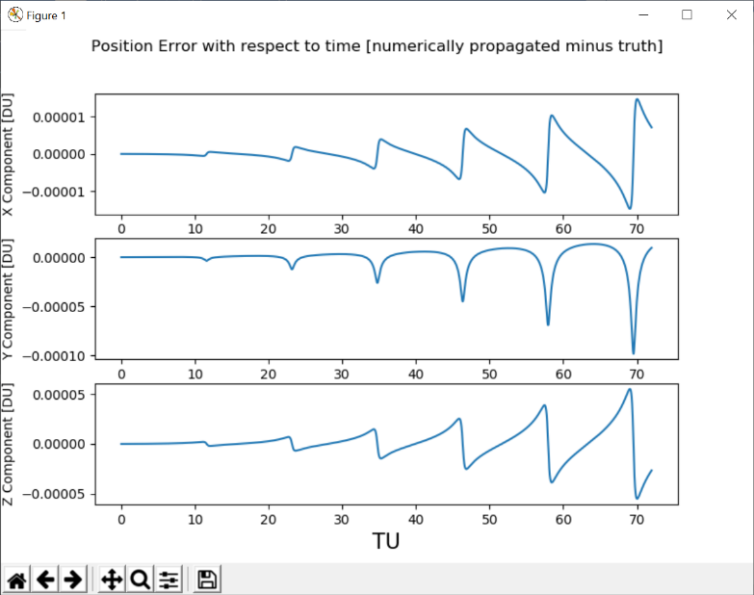
Yes! The oscillatory behavior in the error change matches our expectations. As the position and velocity components calculate for a longer duration of time, the amount of propagated error also increases. While the amount of error increases as the calculation continues, the scale of this error is negligible.

